**SMBCTEX-001 - Design Document**

**Project Name:** IX-RD-PS-Infinity-01 Migración y modernización infraestructura Infinity  
**Client:** Infinity Gifts Souvenirs, Dominican Republic  
**Prepared by:** Intcomex Cloud  
**Date:** June, 2025

**1. Executive Summary**

Infinity Gifts Souvenirs sought to modernize its IT infrastructure to remain competitive in the evolving retail and tourism market. This project involved migrating core systems to Amazon Web Services (AWS), leveraging scalable, secure, and cost-optimized cloud services to enhance performance, reliability, and operational excellence.

**2. Objectives**

* Migrate key workloads (SQL Server, IIS, Active Directory) to AWS.
* Ensure high availability, data security, and compliance.
* Optimize costs through right-sizing and automation.
* Implement Infrastructure as Code (IaC) using Terraform.
* Establish monitoring, backup, and disaster recovery procedures.

**3. Architecture Overview**

**Main Components:**

* **Compute**: EC2 instances for IIS, Active Directory, and custom services.
* **Database**: Amazon RDS for Microsoft SQL Server.
* **Storage**: Amazon Elastic Block Store (EBS).
* **Backup**: AWS Backup for scheduled recovery.
* **Security**: IAM, VPC Security Groups, MFA, Certificate Manager.
* **Monitoring**: Amazon CloudWatch and AWS CloudTrail.
* **IaC Tools**: Terraform with Git integration and CI/CD pipeline.

**Architecture Diagram:**

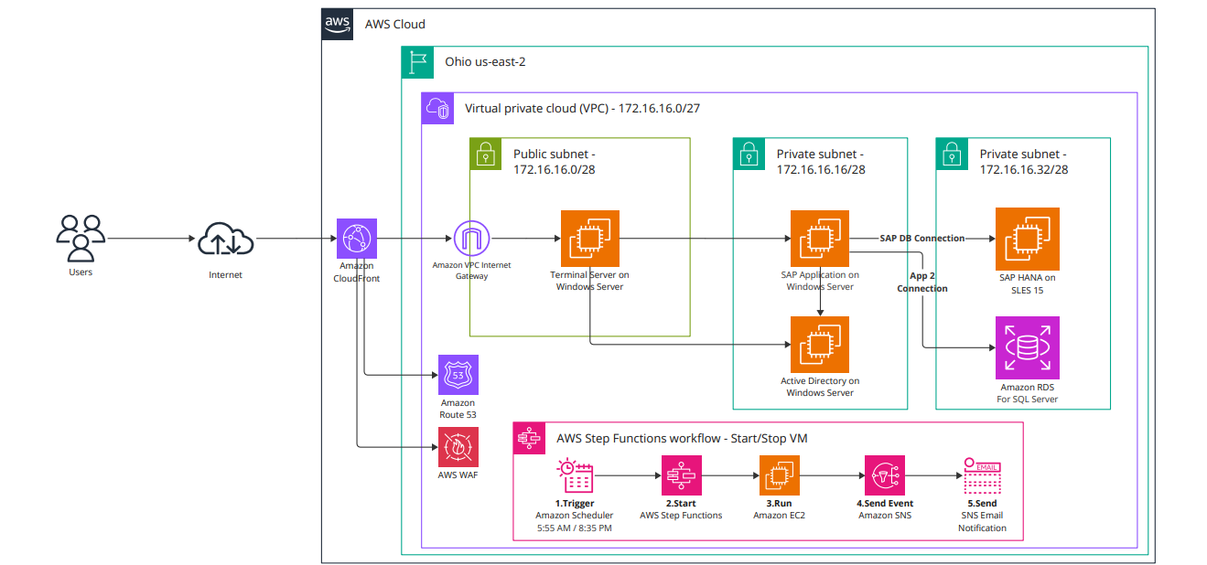

**4. Key Technologies and Services**

| **Technology** | **Purpose** |
| --- | --- |
| Amazon EC2 | Hosting Active Directory and IIS |
| Amazon RDS | Managed SQL Server databases |
| AWS System Manager | Patch management and operations |
| AWS Backup | Automated backup and recovery |
| Amazon CloudWatch | Resource monitoring and alerting |
| AWS CloudTrail | Logging user and API activity |
| IAM | Role-based access control |
| Certificate Manager | SSL/TLS certificate provisioning |
| Terraform | Infrastructure as Code |
| Git + CI/CD | Version control and automated deployment |

**5. Security and Access Management**

* **Root User Protection**: MFA enabled, minimal use.
* **IAM Roles and Policies**: Least privilege model applied.
* **Access Controls**: Role-based with dedicated credentials for partner admins.
* **Logging and Auditing**: CloudTrail enabled.
* **Network Security**: VPC Security Groups with least access rules.
* **Encryption**:
  + **At Rest**: AWS-managed keys for EBS, RDS.
  + **In Transit**: TLS certificates via Certificate Manager.

**6. Operational Excellence**

* **Patch Management**: AWS Systems Manager (manual install after scan).
* **Monitoring**: CPU, memory, disk; alarms on threshold breach.
* **Log Collection**: Centralized in CloudWatch from EC2 and RDS.
* **Runbooks**: EC2 start/stop automation, customer training and documentation provided.
* **Dev/Test Environments**: Isolated QA setup for safe testing.

**7. Reliability and DR**

* **IaC via Terraform**: Automated, version-controlled provisioning.
* **Backup Strategy**: Daily backups with AWS Backup.
* **RTO**: 2 hours
* **RPO**: 24 hours

**8. Cost Optimization**

* **Initial TCO Analysis**: Conducted using AWS Pricing Calculator  
  [Link: <https://calculator.aws/#/estimate?id=78cccb0908e0a965285c91341ddab047107fc693>]
* **Deployment in Single AZ**: Cost-saving measure per client request.
* **Right-Sizing Recommendations**: Based on CloudWatch metrics.

**9. Governance and Compliance**

* Landing Zone setup with secure VPC configuration.
* IAM compliance with client policy.
* Administrative access restricted and audited.
* Ongoing user training and handover sessions (recorded).

**10. Conclusion**

This solution successfully modernized Infinity Gifts Souvenirs' IT infrastructure by leveraging AWS cloud services. It met all technical and business requirements including security, scalability, cost efficiency, and operational readiness.